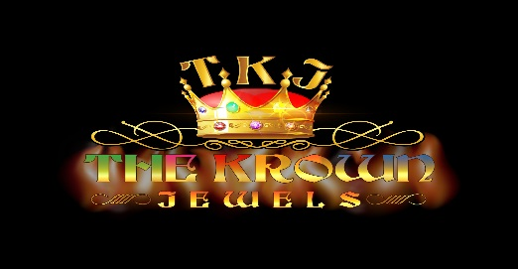

THE KROWN JEWELS Biography
THE KROWN JEWELS (TKJ) is a name coined by Donovan Heslop in the creation of a band for the UK Recording artist PRINCESS and as the house band for The International Reggae Train TV Show (The IRT TV Show). THE KROWN JEWELS is also a stand-alone performing/recording unit with triple threat Jermaine “JERMZ” Mellers in the roles of MD, bass player and lead singer. Having done some recording with "JERMZ" formerly of the Anthem band on a PRINCESS track, Donovan approached him to put the members together. “JERMZ” was able to accomplish the task in record time and TKJ was in rehearsal for the TV show within weeks. TKJ displayed their dynamic approach to music by making their first public appearance on the shoot of The IRT TV Show. They played the theme song with an appreciative audience rocking out to the insistent Paul Sutten dub style drum rhythm. Paul has been replaced by Shaun Scott. Add the unique keyboard stylings of Raymond Stewart and the emotive voice of bass guitarist and lead singer “JERMZ”, informing everyone that it’s “Time to Ride on the Reggae Train, The International Reggae Train … All aboard Now”. Members of the band also supported SHAGGY’s rhythm section on his set during the shoot. TKJ derives its sound from the members all having similar and yet diverse musical influences. A majority of the members come from a Gospel/R&B background.
TKJ’s first single “Sunshine Girl” featuring Princess has been released. Princess appears on the single as an “En-chantress”. The single, a contemporary mixture of, Dancehall, Afro-pop, Reggaeton and EDM, (the sound is called D.A.R.E Groove), is highly infectious with its easily accessible melody “bigging up” all “Sunshine Girls”. The perfect summer record.
Personnel:
MD/ Lead singer Jermaine "JERMZ" Mellers. Jermaine's journey to music was a little different than the rest. His entire family is well known in Reggae music, like the Marley's. Jermaine started on the trumpet, then played trombone, flute, clarinet and then the drums. Years later finally choosing the bass guitar as his main instrument. He has been the Musical Director for GYPTIAN, EVERTON BLENDER, and LUCIANO, just to name a few. Now working in alignment and at the behest of Donovan Heslop, he headhunted the members that make up The Krown Jewels and is also their Musical Director. "JERMZ" has played for nearly everyone in the reggae business.
Next, we have the pulse and driving force of TKJ, Shaun Scott. His dynamic and precise drumming gives The Krown Jewels that punch that fills your spirit with musical goodness. A very accomplished and motivated musician who has a knack for the flare but keeps the music flowing. Shaun has been an experienced and sought after drummer for over 20 years. Sean studied at Kentucky State University and has played with the likes of Junior Marvin, Mighty Sparrow and Eric Roberson, to name a few …
Next we have Oliver Marsh who recently arrived from Jamaica and is one of the two very talented keyboard players, with TKJ. He started his musical journey via the hotel circuit in Jamaica. As the newest member of the band there is great anticipation to see his talent expand the core vision of TKJ.
Raymond Stewart’s musical journey began similarly, in the church in Jamaica. He came to the States and joined a Gospel band, Deon Kippings and New Covenant. He wanted to extend his musical range into reggae, still incorporating his Gospel influence. He's been playing for a plethora of artists such as Collie Budz, Everton Blender for the last couple of years. A very accomplished musician, Raymond adds a youthful, joyful, presence which is felt and heard when listening to TKJ.
Contact: Don Heslop, thekrownjewels18@gmail.com, 347 213 3371

